National Preceptorship

Improving Nurse Retention:
The case for investing in preceptorship

Version 1.5 – August 2022

In December 2021 London NHS Region was commissioned to undertake a National Programme to oversee the delivery of a collectively agreed set of standards and a framework for good practice in implementing preceptorship for newly registered nurses and nursing associates along with an accreditation framework which might subsequently be expanded to other professional groups.
This programme was based on the CapitalNurse work undertaken by London. CapitalNurse was established in July 2015 by the London Chief Nurse and the Health Education England Regional Director and was jointly sponsored by Health Education England, NHS England and NHS Improvement. By the end of 2019 all of the London Trusts had adopted the preceptorship framework and many have received accreditation
This document supports how implementation will benefit your organisation. This briefing sets out the return on investment a trust/health provider can expect from adopting the framework. Fundamentally the new framework is premised on the value that it will be a means of supporting and developing newly registered nurses so that their confidence, skills and behaviours can flourish, and their careers can progress. Fulfilled nurses, who are supported at this crucial stage of their early career, are more likely to stay with their first employer, using their growing knowledge and experience to benefit their patients, which in turn leads to improved clinical outcomes. Good quality preceptorship in year one for new graduate nurses has an impact on retention, and furthermore, these nurses are more likely to be retained for up to five years post qualifying. In summary, investment in preceptorship provides trusts with triple returns: it improves retention, it increases nursing skill and it produces economic value.
What is preceptorship?
Preceptorship is defined as:

‘The purpose of preceptorship is to provide support, guidance and development for all newly registered practitioners to build confidence and develop further competence as they transition from student to autonomous professional’ (National Preceptorship Project, 2022)

The requirement in principle for preceptorship in nursing and midwifery was first set out as part of the UKCC (now Nursing and Midwifery Council) proposal for Project 2000 in1986. In 2008 the NHS Next Stage Review emphasised the necessity for a period of preceptorship for all newly registered healthcare staff, including nurses (Department of Health, 2008) and a framework for preceptorship was subsequently published (Department of Health, 2010). Since then there has been sporadic non-recurrent funding to employers, from strategic health authorities and Health Education England (HEE), to invest in preceptorship. The value of preceptorship was reiterated in the Nursing and Midwifery Council’s (NMC) recently published principles of preceptorship 2020, which was developed in collaboration with the Chief Nursing Officers, the Chief Midwifery Officer in England and Scotland and the Lead officers for midwifery in Northern Ireland and Wales.

Preceptorship occurs within the first year of qualification and is focused on easing the transition from student to registered practitioner. It is intended to be facilitative and enabling. It is not basic induction and mandatory training, a substitute for performance management processes or simply a distance or e-learning for a newly registered practitioner to complete in isolation.
Potential benefits of preceptorship for new registrants include developing confidence, positive socialisation into the working environment, increased job satisfaction, feeling valued, respected and invested in by their employer, increased commitment to the employer and profession - all of which are linked to patient satisfaction, quality of care, retention and enhanced recruitment. Those supporting new registrants (the preceptor or preceptorship programme lead) are also likely to feel positive about their work place as it is supportive, and they are able to develop others.
What do employers need to have in place for good Preceptorship?
Based on international evidence and our experience over the past five years, it is
recommended that employers should have a programme in place that meets the
standards and guidance set out in the National Framework.

This includes:
- A trust preceptorship policy and an organisational lead for preceptorship
- Defined roles for preceptor, preceptee and preceptorship lead
- A structured preceptorship programme that has been agreed by the Executive Nurse
- Protected time for preceptorship activities including a minimum initial supernumerary programme
- Compliance with HEE Standards (2015), NMC Principles of Preceptorship (2020) and National Preceptorship Framework (2022)
- Alignment with the organisational appraisal framework.

Example costings for preceptorship in NHS
Example costings for preceptorship, based on a cohort of 100 newly registered nurses, are set out below. These example costings are based on information we have about existing programmes. These are indicative and will vary depending on your organisation’s individual model (it is accepted that this example may not be reflective of some smaller organisations). The figures below also indicate additional allowances for London (inner, outer and fringe).

Table 1: Basic salary costing
Activity | Cost – based on 100 Newly | No high cost allowance | Inner | Outer | Fringe
 | Registered Nurses
 |  | Basic with pension and NI | 20% of basic salary | 15% of basic salary | 5% of basic salary
A preceptorship lead | 1 WTE  mid band 7  £42,121 pa | £53,350 | £62,447 | £60,173 | £55,624
Newly registered Nurses | 7 days per year
6 days protected time for preceptorship programme | Bottom band 5
1 day preceptorship meetings and reflection practice | £31,149 | £103,830 | £125,752 | £120,271 | £109,310
Facilitators of preceptorship programme | 6 days per year,
 | 1 facilitator for 10 NRN’s,
 | Midgrade band 6 – 0.3 WTE (60/210 days)
 | £42,862 | £12,859 | £18,734 | £17,265 | £14,328
Preceptor time to support preceptorship meeting | 8 hours per year  Band 6  £34,172 | £137 | £198 | £192 | £177
 | Total per 100 NRN | £170,175 | £207,131 | £197,900 | £179,440
NB – All costs are based on a 7.5 hour working day. Learning material and rooms costs are not included
All costs are calculated as per NHS Agenda for change (AfC) pay rates. They are based on base rate and do not include overheads, usually calculate as 25% of base in addition.
The average cost for recruiting (advertising, admin, HR) a Band 5 nurse would be between £4,670 per nurse i.e. £31,148 * 15%) to £7,545 (£37,726 * 20%). This calculation is based on adding 15-20% overhead contribution to the above costs.

Why Should Employers Invest?
The NHS people plan outlines the need for action to grow our workforce, train our people, and work together differently to deliver patient care. There is evidence to show that investment in preceptorship leads to improved retention.

Graph 1 shows us that that the number of newly registered nursing and midwifery staff in London have remained working in London within the same professional group (i.e., haven’t moved into another role but remained within the NHS workforce).

The number of newly registered nurses retained was 82% (2018), and 86% (2019) based on data captured between 2013 and 2019 in London since the introduction of the CapitalNurse Preceptorship programme. Investment in quality preceptorship programmes facilitate retention of newly registered staff and provides a return on investment.
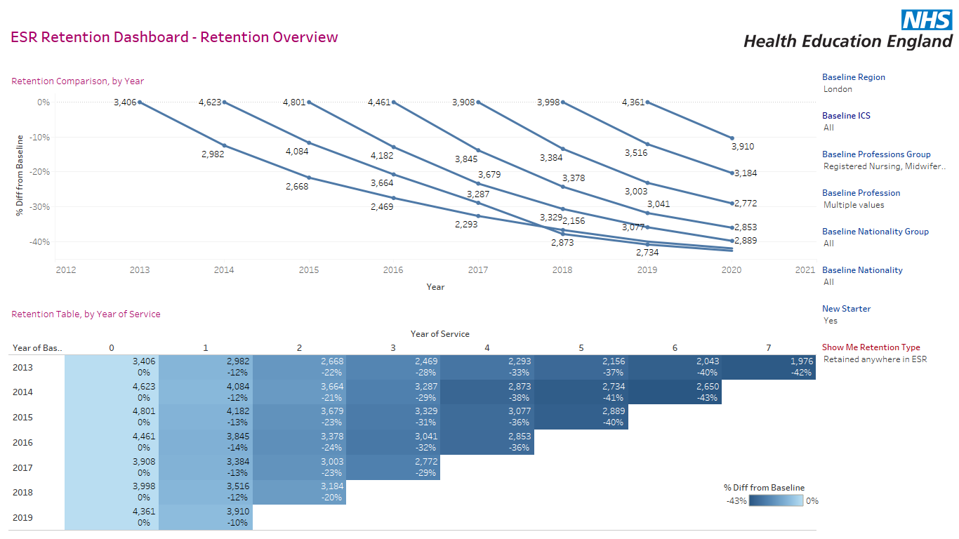

Graph One shows the number of newly qualified registered nursing staff in London who have remained working in London within ESR (i.e., have remained in the NHS workforce, but could have moved into a different profession or region).
Between 2013 and 2019 between 10% (2019) and 14% (2016) of NQ staff on longer work in the NHS within one year.

Graph 2 and graph 3 show the retention proportions of nurses from cohorts between 2017-2021.
For this analysis the nurses in the cohorts were filtered by the following requirements:
- Nursing & midwifery workforce is defined an individual being employed on a substantive contract with an occupation code defined by the NHS Occupation Code manual that means they work in the nursing & midwifery workforce.
- A member of staff is defined as Newly registered if they were employed in an AfC Band 5 role on the bottom spine point and had not previous been employed on ESR in a nursing & midwifery role.
- Those identified as NQ nurses & midwives were then tracked over each following year’s data to identify whether they remained within the profession within London.

Graph 2 shows an improvement in staff retention in 2021 which is a positive outcome of launching CapitalNurse. This in comparison to the data in Graph 3 shows a decline in staff retention across England in the same time frame.

Analysis of nursing and midwifery workforce turnover in London
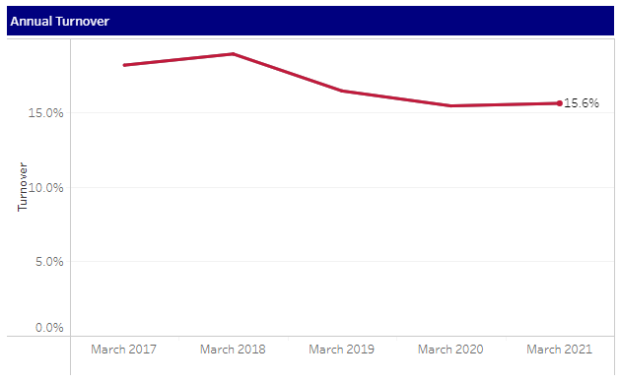
Graph 2: Data Source - ESR data via HEE London ESR Retention Dashboard.

Registered nursing and midwifery workforce turnover in England
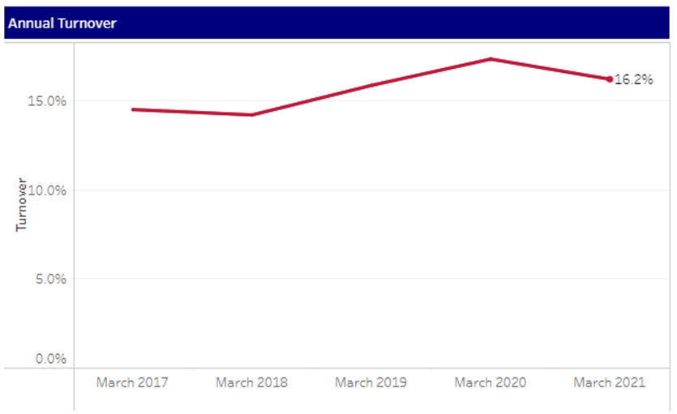
Graph 3: Data Source - ESR data via HEE London ESR Retention Dashboard.

Authors
Desiree Cox, Programme Lead
Jane Wray, Clinical Advisor
Raleen Fernandes, Project Manager
Contributors
Matthew Rassell, Workforce Planning Lead, London Workforce and Intelligence Team, Health Education England
References
- CapitalNurse business case template
- NHS England and NHS Improvement Business case guidance

